**LAB -2**

**FILE_MANIPULATION THRU WINDOWS CMD LINE**

NAME : SREENIDHI GANACHARI

REGISTRATION NUMBER : 19BCE7230

SLOT :L- 39-40

QUESTION –

All the execution needs to be in cmd. No GUI. ​

Note: Execution should be from any relative path ​

Create 10 files (txt, docx or any) and sub folders using your roll number followed by SS and numbering.​

Try to delete all the files in 1 folder (last child)​

Try to delete all the files which are in docx type in 2nd folder (second folder from root)​

Try to delete all the files which are in docx type starting with SS in 3rd folder ​

Try to delete all the files starting from SS11 to SS20 in the root folder

ANSWER-

1)

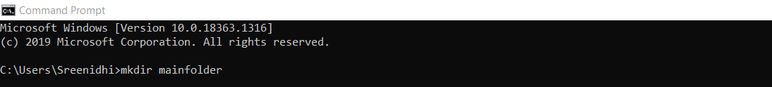



Created a folder .

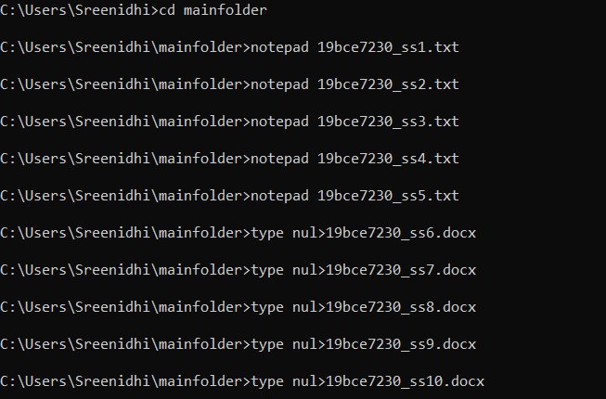

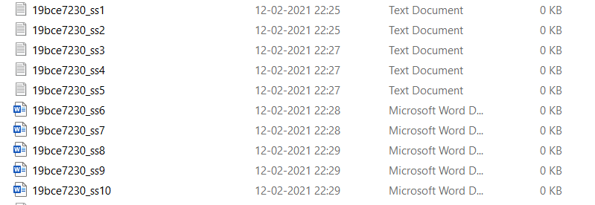

Created files in the main folder



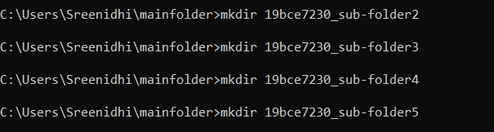

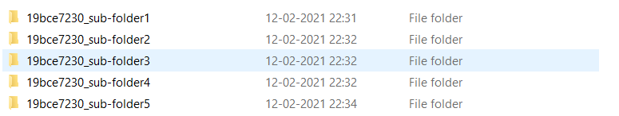

Created sub-folders in the main folder

2)

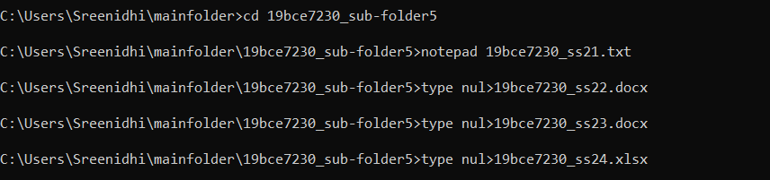

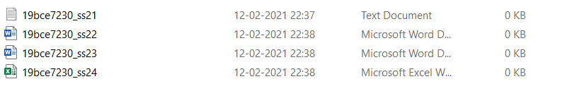

Created files in the folder 5 (last child)



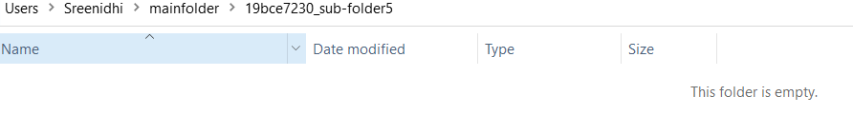

Deleted all files in 5th folder

3)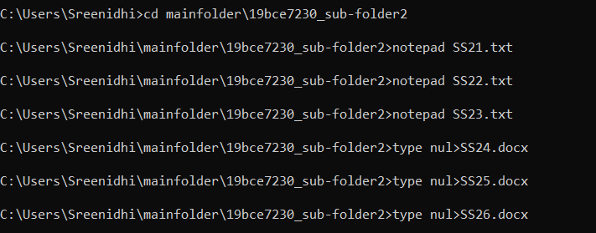

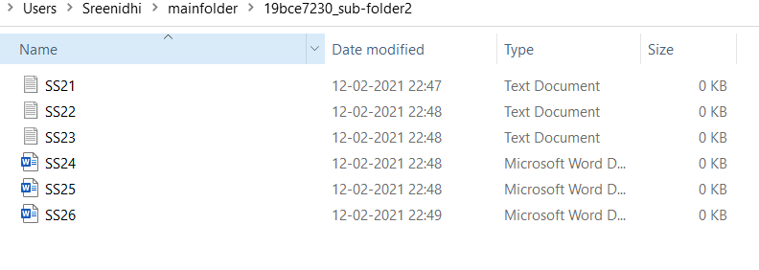

Created files in folder 2

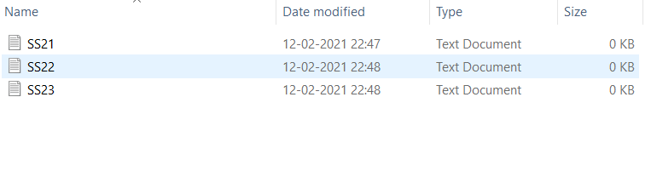

Deleted all the docx files in the 2nd folder

4)

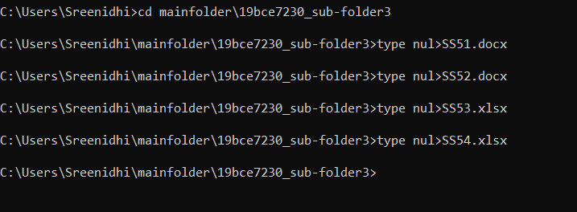

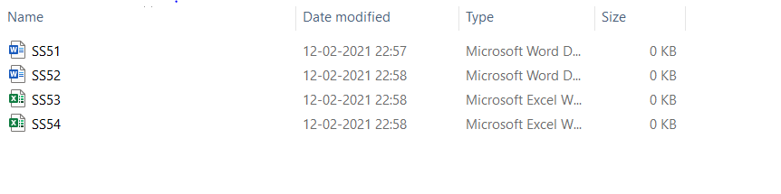

Created files in the 3rd folder



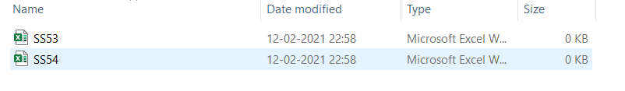

Deleted files with extension docx and starting with SS

5)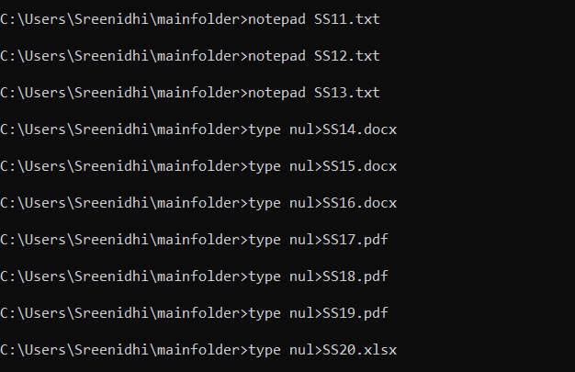

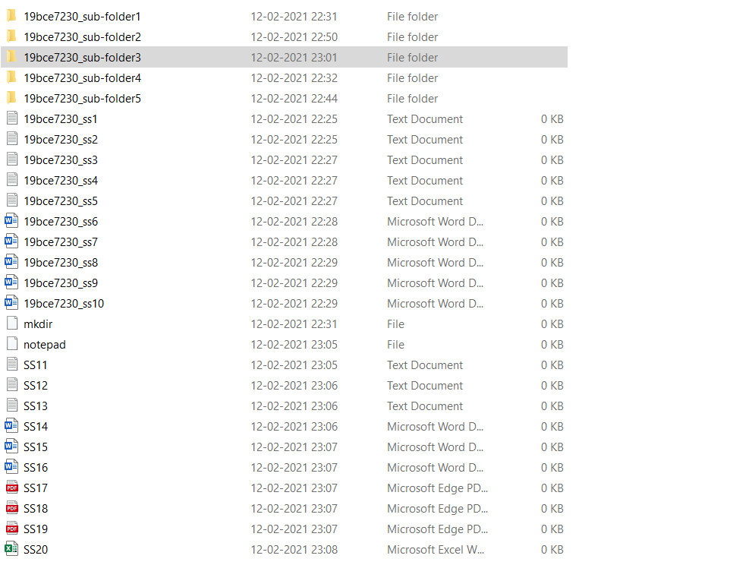

Created more files



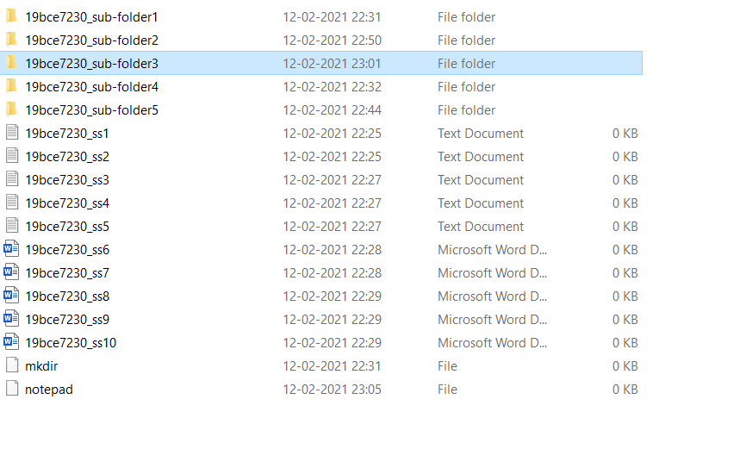

Deleted files from SS11 to SS20